**Motor test results**

These datas are taken from the instants where the driver circuit is directly connected to the motor. In this part of the report, the current and voltage waveforms at various speeds of the motor will be observed.

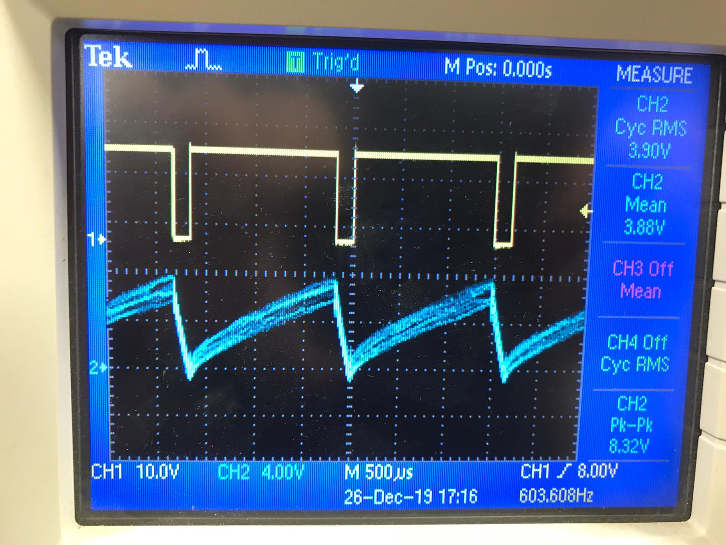

Figure??: the Armature current where the motor at rated speed at no load

* The armature current shape is like sawtooth because there is no additional inductor for filtering purposes
* It indicates that torque is changing always at the operation interval
* However, since the motor has its inertia like mechanic capacitor its speed does not change instantly and this inertia will keep speed almost constant during the periodic interval.

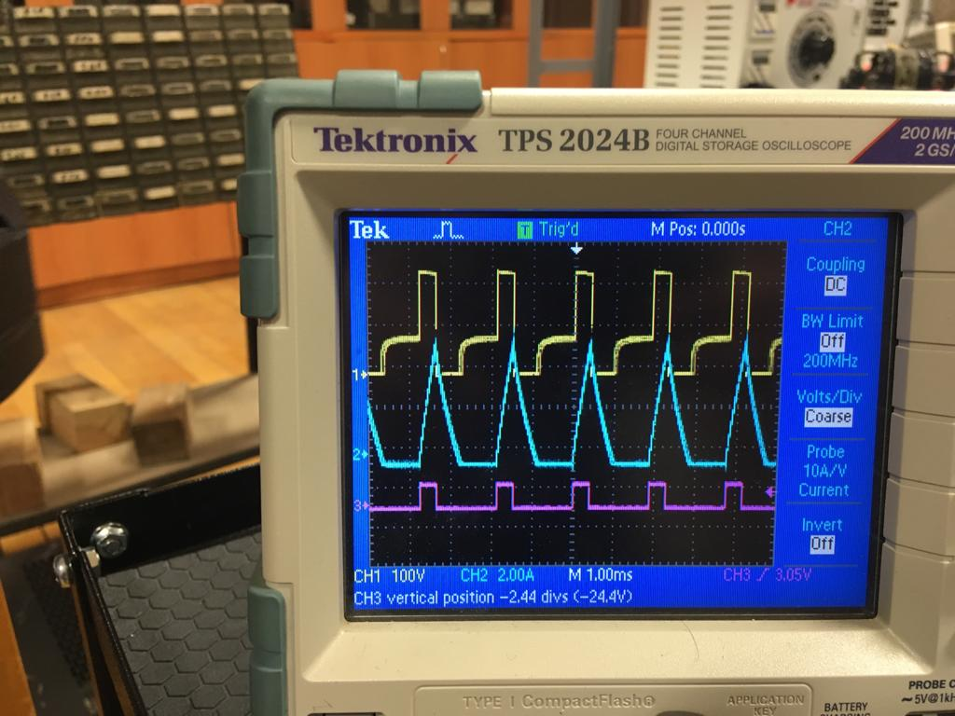

Figure??: motor is at 540 rpm(red:duty cycle,yellow:mosfet Vds, blue:armature current)

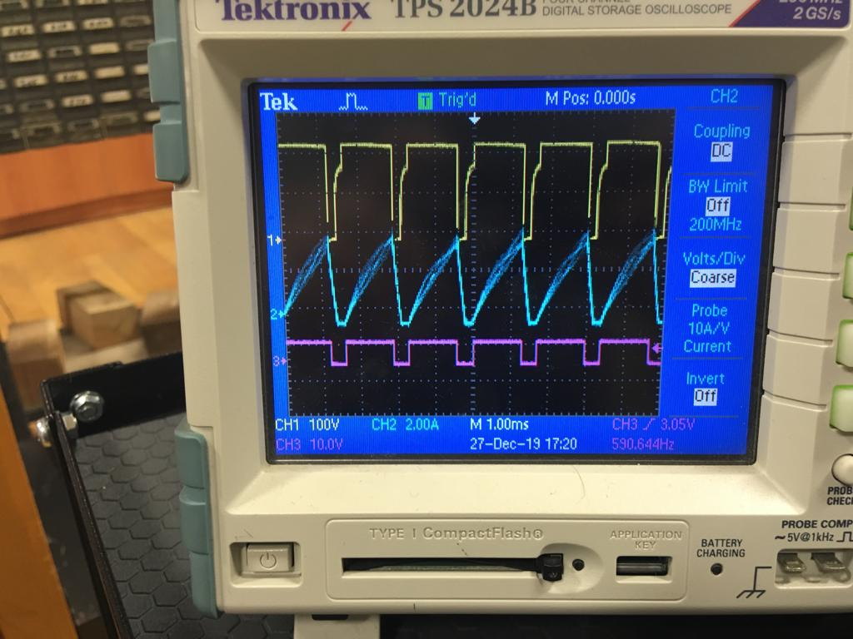

Figure??: motor is at 800 rpm(red:duty cycle,yellow:mosfet Vds, blue:armature current)

* These are datas which are take from the motor at some speed and especially when it is discontinuous conduction mode.
* Since we do not have any inductor in the circuit we can not adjust the driver such that for all operating ranges of the duty cycle it will be in CCM.
* (***) The most interesting and nice waveform is belongs to mosfet (yellow ones) because since the driver is in DCM when the current of the inductor is zero and the mosfet gate signal is active in other words, when the mosfet is on and inductor current is zero “Back EMF” of the motor is directly seen from the mosfet drain node.

So, this is the reason why its voltage waveform makes horizontal constant voltages for a small amount of time.

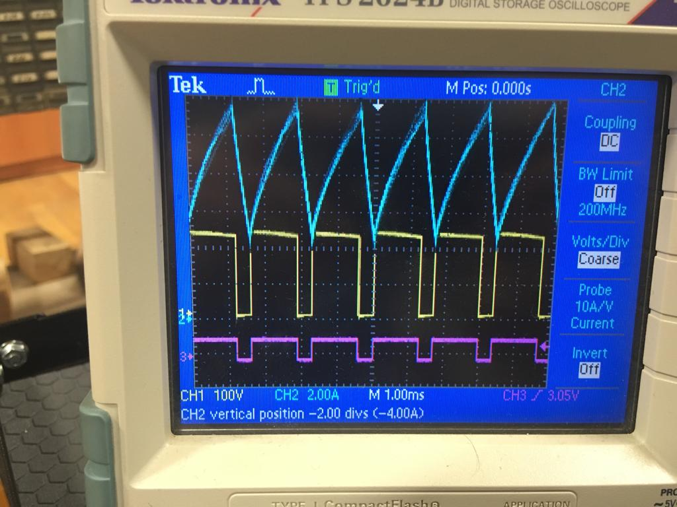

Figure ??: motor is at 1300 rpm and in continuous conduction mode

* Different from the DCM mode , there is no back emf seen from the mosfet drain node.

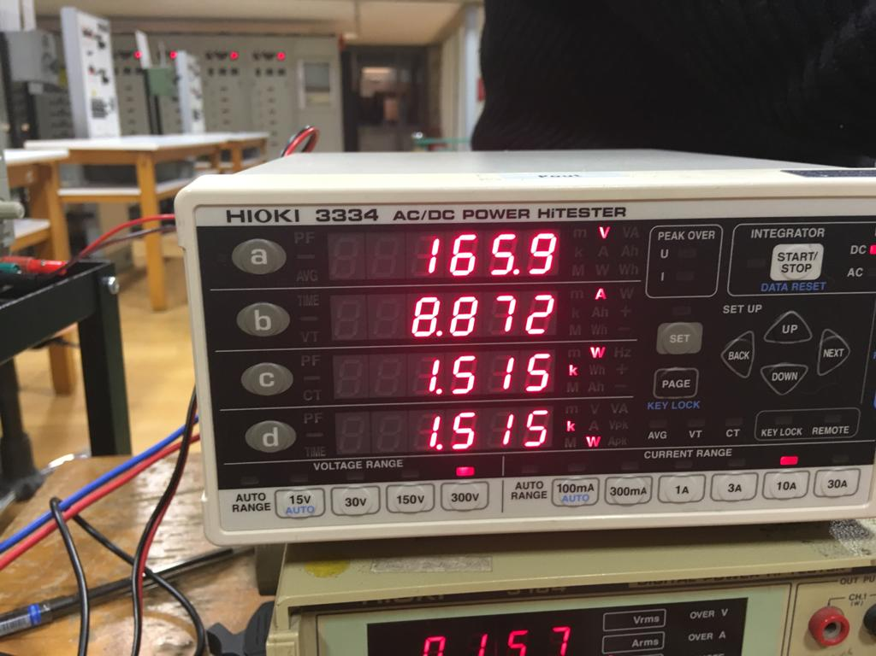

Figure??: motor power output and output current (resistive load case)



Figure??: motor is at loaded with the kettele and the current is huge now (900 RPM)

* When the resistive load is connected there will be torque disturbance at the load and this will decrease speed since more torque is required to drive this new load.
* When the torque is increased the current also be increased and it reaches like 8-9 amperes.